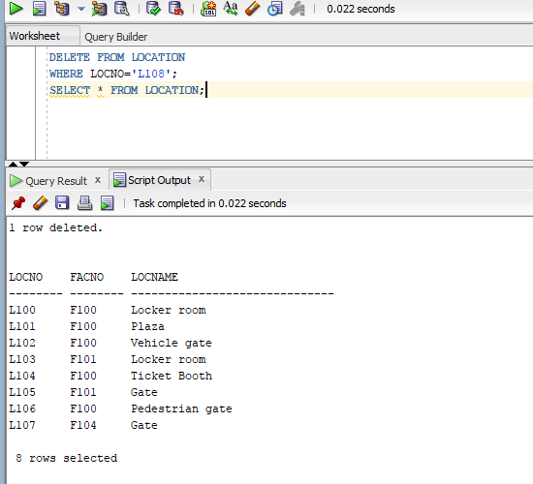
DELETE FROM LOCATION WHERE LOCNO=’L108’;
SELECT * FROM LOCATION;

